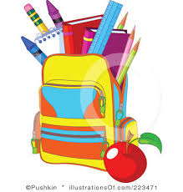
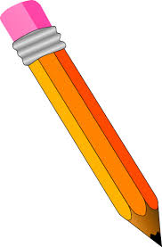
Rhawnhurst Elementary School
2018-2019 Kindergarten Supply List
Below is a list of supplies that your child will need to have at school:
Student supplies
- A school bag with your child’s name clearly labeled. The school bag needs to be big enough to hold a marble copybook and folders.
- 2 marble copybooks with your child’s name on them
- A box of 12 sharpened pencils – Jumbo pencils: Ticonderoga Beginners
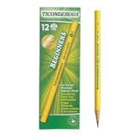
- 6 large glue sticks
- 2 large folders with pockets
- 1 large pencil case/box
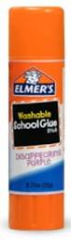
- 1 pack of thick Crayola Washable Markers
- 1 box of large Crayola Crayons – 8 colors
- 3 black Expo Dry Erase Markers
- 1 Dry Erase Eraser
- 2 Reams of Copy/Xerox paper
- 1Communication folder purchased from school - $2.00
- 1 yellow Rhawnhurst trip shirt - $8.00
- 1 box of 2-Gallon Ziplock Baggies (or store brand)
- 1 box of Ziplock Sandwich bags (or store brand)
- 1 pair of headphones
- A complete change of clothing placed in a plastic bag labeled with your child’s name
*In black marker, please label all supplies with your child’s name.

Classroom shared supplies:
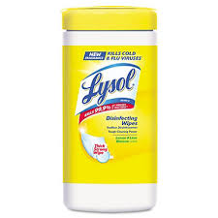
- 1 box of tissues
- 1 bottle of hand sanitizer
- 1 container of Lysol Wipes (or store brand)
- 1 container of Baby Wipes
- 1 Roll of Paper Towels
Home Assignment supplies – please keep at home
- Glue sticks
- Crayons
- Pencils
- Scissors
- Magazines, newspapers, circulars, advertisements

**A notice will be sent home when your child’s supplies need to be replenished.
Bring all supplies to the Kindergarten Interview

