Supply List
Grade 5
2018-2019
Rhawnhurst Elementary School

- 5 folders
- 8 HARDBACK COMPOSITION ONLY (NO SPIRAL BOOKS)
(Reading, Math, Social Studies, Science, Writing, Morning Work, Creative Writing, Science Enrichment)
- Headphones (to stay in school)
- 12-inch/cm ruler
- 1- Pack of Loose leaf (100 sheets only)
- glue stick
- crayons and/or colored pencils
- Markers
- 12 SHARPEND PENCILS IN SCHOOL AT ALL TIMES
- 2 boxes of tissues
- Scotch tape
- 2 yellow highlighters
- 1 bottle of hand sanitizer
- 1 container of Clorox wipes (or store brand)
- 2 dry erase markers
- Pencil sharpener (to be used at home ONLY)
- $7.00 to cover the cost of Times For Kids Magazine subscription, which is part of the fifth grade curriculum
- $2.00 school communication folder

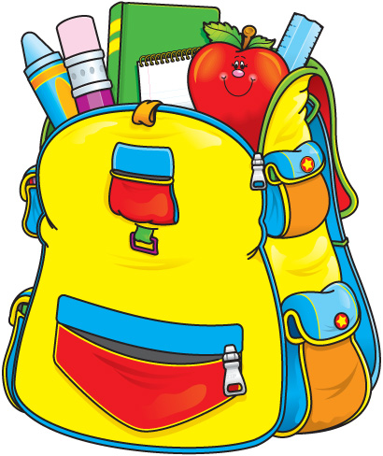

Thank you for your support!

